

MentorLink

B.SC Hons in Interactive Digital Media

Final Year Project   
May 2024

K00255116 | Farhan Saeed

Technological University of the Shannon: Midlands Midwest Department of Information Technology

Student Name: Farhan Saeed

Student Number: K00255116

Project Title: MentorLink

Date Submitted: 10/05/2024

Plagiarism Disclaimer I understand that plagiarism is a serious offence and I have read and understood the college policy on plagiarism. I also understand that I may receive a mark of zero if I have not identified and properly attributed sources that have been used referred to or have in any way influenced the preparation of this assignment. Furthermore, I understand that I may receive a mark of zero if I have knowingly allowed others to plagiarise my work in any way. I hereby declare that this assignment is my work based on my personal study and /or research and that I have acknowledged all material and sources used in its preparation. I also declare that this assignment has not been previously submitted for assessment.

Contents

Acknowledgement. 5

Abstract: 7

Introduction: 10

Front End and Design of the application 15

Moodboard: 16

Logo: 17

Color Sheme: 18

Icons: 19

Typography: 19

Poster: 20

Website: 21

Wireframes: 21

Final Website: 22

Android App Development: 25

Learning Kotlin and XML 29

APIS: 30

Android's Location APIs 30

Registering the user information and sending it to the Firebase Database 32

Profile view: 38

Find a Mentor: 39

Lessons learned: 40

Figure 1 User Persona 13

Figure 2 UI Mentor Link 15

Figure 3 MoodBoard 16

Figure 4 Logo Full 17

Figure 5 Logo Icon 17

Figure 6 Color Scheme 18

Figure 7 Icon 19

Figure 8 Poster 20

Figure 9 Website Structure 21

Figure 10 Website Wireframes 21

Figure 11 HomePage 22

Figure 12 About Page 23

Figure 13 Testimonials 23

Figure 14 Contact Us 24

Figure 15 Register 26

Figure 16 Student Registration 27

Figure 17 Realtime Database 28

Figure 18 Login 29

Figure 19 Location APIs 30

Figure 20 Location API 30

Figure 21 Menifest XML 31

Figure 22 JSON 33

Figure 23 Authentication 37

Figure 24 Profile View 38

Figure 25 Find a mentor 39

# Acknowledgement.

I am grateful for the unwavering support and inspiration of Farakh Saeed, my brother, who’s struggle has inspired mine. My family’s upbringing and commitment to my education from the young age and instilling in me the work ethic and dedication to take responsibility for my education and life in general. I would also like to thank my teachers, mentors, companions, and community I met in Limerick, Ireland during my 4 years of stay here during my BSC Hons studies. My education, more than academic, was spiritual and deeply personal which was not expected. I met wonderful people, experienced beauty, love, anxiety, stress, and rollercoaster of human emotions that all served the greater purpose of propelling me towards my greater self and actualizing my potential. During these four years of journey, I have undertaken projects that younger me couldn’t imagine. I expanded my mind, consciousness, compassion, and intellect beyond what I imagined a university degree could do. I was always under the supervision of someone, watched and mentored in every aspect of my life that I was expected to master. From finances, time, emotions and body. This education has been immensely and deeply transformative to my core, something that was not possible for me to fathom during my first day in TUS. I arrived in 2020, and after finishing my quarantine, the level 5 lockdown was imposed that caused immense anxiety and stress for someone who never travelled abroad or had an independent life before. However, the international office and various student body personnel and Lorraine Callanan understood the situation and helped anyway possible. Those days will forever be etched in my memory.

Few noteworthy people that I met who taught me about media, journalism and technology apart from my university professors are:

1. Richard Lynch – Taught me the value of positive attitude, self-expression, and journalism.
2. Ronan Ryan for offering me my first job in Ireland as a web developer.
3. Robbie Kiely for my personal development and teaching me the value of compassion, communication, and kindness.
4. Usman Mangla for his friendship, positive criticism, and friendship.

Nearly every person that I’ve met in Limerick during my education has made me feel at home, contributed towards my growth and has given me guidance that has been instrumental in realization of my full potential, and I shall forever be grateful to all these individuals who supported me in my highs and lows.

# Abstract:

As stated before, during my 4 years of university education in Ireland, I’ve met some of the most amazing people in the world. I say that without any exaggeration, they taught me lessons in spirituality, consciousness, human connection, higher order thinking, vision management, perception management, self-care, and love. They also taught me about becoming a better person in all aspects of my life. Now these people, although met abruptly, but I believe it to be a predestination has solved the problems in me that I didn’t even know I had. They taught me about controlling my inner self, micro expressions, my inner psyche construct, and nature of life in different realms. I delved into corporate word, in nature, I met climbers and rafters, I met DJs, and florists. Nearly every person was a master at their craft and taught me about dedicating the life in pursuit of study, self-mastery, and excellence.

One such encounter was my work placement in PBC Biomed where I met people that I got along with and then there were people who I didn’t get along with. Both kinds of people taught me about my own nature and what kind of energies, conversations, work, and jobs I gravitate towards. However, I feel extremely lucky and privileged to have been there, I feel that not everyone get’s that same chance. Encountering a lot of mentors and people in the span of few months really puts things in perspective. Not just academically, but also in the scope of wider aspects of professional and personal development.

In this spirit, for my final year project, I decided to create an app that can culminate my experience of 4 years into one project. This app has the essence of my 4-year journey in Ireland and defines my capabilities, my vision, and my experience. I wanted to question things, find the answers that bubbled from introspection, process new experiences that didn’t have any blueprint in any textbook. The only way my new and vivid experiences could be processed internally for me was by meeting diverse group of people and integrating their life’s experiences into my learning. These people from their stories reflected parts of myself, and my experiences and helped me master my new reality.

Studying abroad for me was a dream because I wanted to explore a more global viewpoint about things. This meant transcendence above mundane, seeing things differently and encountering things that neither I, nor anyone around me have encountered. It’s about exploration into unknown, understanding the journey of education and integration of knowledge. Then using this knowledge for my benefit and then the benefit of people around me has been an enjoyable, stressful, and eye-opening experience.

So, the way mentorLink operates is to specifically create a community of mentors who have experiential knowledge in the realms that stands out. People who have gone off the beaten path have stories, passions and life that resonates with very few people. However, those few people are looking for each other, for mentorship, discussions, and exchange of ideas. And there are no classes that can be organized in groups locally, or by any organizations. These teachings can only be transferred among chosen ones, trailblazers, and risk takers. Therefore, what mentorLink provides, is location based, community-based classes, mentorship sessions that are organized individually.

For example,

1. have a network engineer in Google for 25 years coach a fresh graduate about intricacies of color-coding wires.
2. Shaman teaches about journeying and vision quest.
3. Equestrian teaches about cross breeding horses.
4. A priest turned stripper teaches about modesty, self-expression, and persona.
5. Druid teaches about pagan spirituality.

Though the present reality of the app is technologically very simple, the stories behind this project has been immensely enchanting, bold, sad, and eye opening.

# Introduction:

“When the student is ready the teacher will appear. When the student is truly ready, the teacher will disappear” Tao Te Ching

MentorLink is a platform that has been designed to cater to various aspects of modern education and the need of an external mentor that has experiences that can offer wisdom, guidance, map, and motivation. Although there are no chance encounters, I believe that when the mentors and mentee sign up, there is always a way they can find themselves. MentorLink just tries to be a helping hand in that process. This app aims to find the perfect match based on the location, goals, and aspirations of students.

**You may access the android studio project and website files here:**

<https://tusmm-my.sharepoint.com/:f:/g/personal/k00255116_student_tus_ie/Egor1I1QswZGn7nA-IEyaGMByepdXVyjJakUpCDxtn5Gsw?e=sPKFQx>

Please note, the android studio files in a rar file, otherwise it wasn’t uploading.

Now, I am delighted to present the following work done in the FYP:

1. MoodBoards and Target Audience

2.     Logos and Color theme

3.     Website

4.     In App Login

5.     In AppRegistration

6.     User Data fetching from Firebase

7.     UI

8.     Profile view of the user

9.     Main app screen for Mentor

10. Main App screen for Mentee

In the later stages of development, I want to incorporate features like scheduling tools, progress tracking, secure communication channels so that the whole experience is seamless and productive for both mentors and students. This app, in future, will operate of a fee-based model where mentors will be able to set an hourly rate for themselves. In doing so, the mentors can have assurance that what they must teach will be taken seriously by the students. And for the students, this fee is like an investment into their person.

Education industry is full of competition now. There are a lot of different online platforms that offer upskilling, coaching and mentorship. Platforms like Superprof can help students find teachers for their academics like music, maths, and physics. Skillshare offer multiple creative courses online such as painting, music, art, graphics, and media. Khan academy provides a vast library of lectures on different topics that can help students in A Levels, O Levels, and other general exams.

However, the unique selling point of MentorLink is the community that engages with this app that is full of eccentric, off the beaten path, spiritual people that offer insights that very few other places can offer. Furthermore, mentorLink has a match feature that matches these mentors to students based on their location and geographic proximity. This ensures that students aren’t given a cookie cutter lesson but rather taught through active participation how things are done, psychology and mindset behind it and the planning that’s required.

The education sector is growing rapidly as well as mobile app industry. Two industries have an untapped potential. MentorLink caters to individuals who are seeking personalized guidance beyond generic resources, Professionals seeking career advancement by connecting them to industry experts and learners seeking skill development or explore new areas of interest.

Figure 1 User Persona

In future, I want to implement a personality matching algorithm with the new AI mobile technologies that have come out in recent months. This matching algorithm will be able match people together who would pair up perfectly with each other. For example, plotting a person’s big five model of personality and then pairing them up with someone who has totally opposite profile. So that both people can be able to see how both accomplish the tasks. Such pairings, often done by executive consultants in corporate, uses a feature called Gallup that put’s human talents in 34 categories in rank order for individuals. Then the consultants’ pair them up together so they both can benefit from each other’s opposite personalities and perspective. I believe, I can use big five model of personality and pair people together that can be an immensely educational and learning experience for students as it has been for me during the work placement. Furthermore, this feature will be able to point out the strengths and weaknesses of the students and what skills they should develop based on the underlying talent that they have.

# Front End and Design of the application

While designing the mentorLink app, I prioritized minimalist design that is to the point, easy to use and engage with. For the research purposes, I utilized online platforms such as pinterest, Instagram and google images. In figure 2, you can see the intended final design that I want to implement for the MentorLink. For the design purposes, I used Figma, Adobe Photoshop CC and Adobe Illustrator CC (For vector icons).

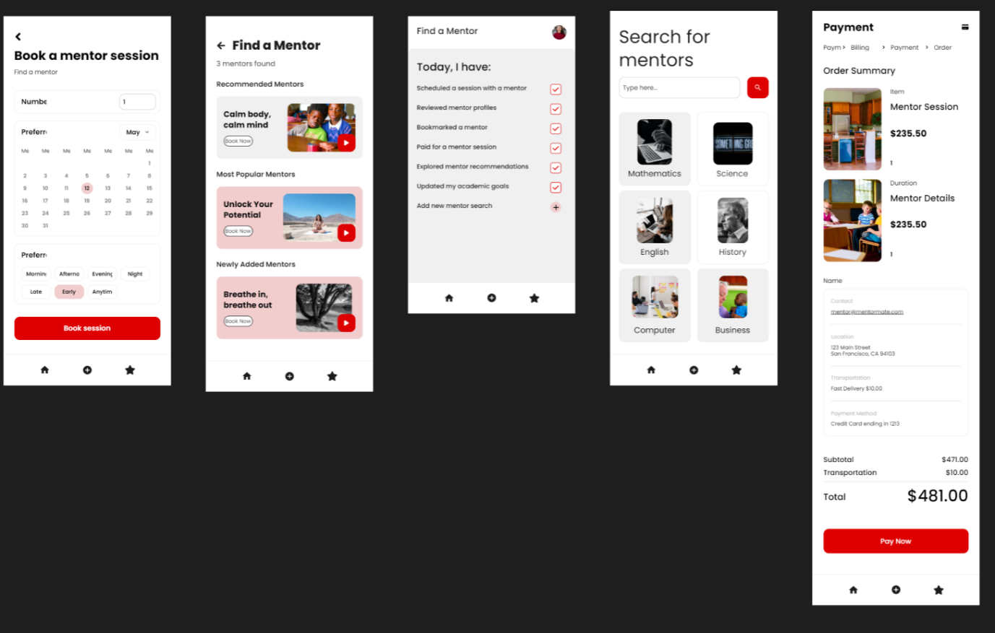

Figure 2 UI Mentor Link

The poster, user interface (UI), and front-end design of MentorLink and other various designs are created using design software tools including but not limited to Adobe Creative Cloud suite, which includes applications like Photoshop, Illustrator, and XD. Figma and Adobe XD are specialized tools for designing user interfaces and prototypes. These tools offer features for creating wireframes, mock-ups, and interactive prototypes, which are crucial for designing the visual aspects of the app and website.

## Moodboard:

Although there’s hours of research into the UI and app screens, app design elements in my hard drive, I have picked this one image that encapsulates most of my intentions with the chat feature, opening app screen and other various screens throughout the app. This mood board doesn’t demonstrate exactly the content I will put into the app but rather an over arching design ideology and theme.

Figure 3 MoodBoard

## Logo:

In the design and sketch process of MentorLink logo, I wanted to symbolize flight, freedom through knowledge, growth, and empowerment. So, I sketched out this logo and vectorized it using Adobe Illustrator CC:

Figure 4 Logo Full

Figure 5 Logo Icon

Just as wings symbolizes freedom for birds, I used that symbol here to demonstrate growth and empowerment. The first logo is the full one which will be used on merchandise, websites, on app screens. The second logo is shorthand version that can be used in smaller screen areas such as website favicon, toolbars or small menus. One minute aspect of the app is upward trajectory of the wings that symbolizes learning, explore new horizons and elevation of consciousness and knowledge. Overall, the wings in MentorLink's logo serve as a visual reminder of the commitment to fostering a supportive and nurturing environment where individuals can spread their wings, soar to greater heights, and achieve their aspirations.

## Color Sheme:

I used this colour scheme in the figure below because I researched most of the education sector UI and found out that red is the least used colour in this industry. To make my platform standout, I used the bright red #DE0000 and muted pastel red #F2CDCD. The light grey background will be used to separate the app screen from totally white background which can be straining for the eye due to high brightness of the mobile screen in today’s age.

Figure 6 Color Scheme

## Icons:

I used the following icons repeated across the app with the color scheme as mentioned before.

Figure 7 Icon

## Typography:

HELVETICA – HEADING

Helvetica – Paragraph

Helvetica – Caption

## Poster:

This poster was designed using Adobe Photoshop CC and Adobe Illustrator CC. The header image was taken from the website called Unsplash which is a free royalty free image website. The poster in the graph illustrates the impact mentorship has on the individual’s ability to perform a job before and after having a mentor. The QR in the bottom is a link to the one drive where my final year project is currently stored.

Figure 8 Poster

## 

## Website:

The website is locally hosted now and was built on html and css. It follows the same color scheme as the poster. The wireframes are made in Adobe Photoshop CC.

### Wireframes:

Figure 9 Website Structure

Figure 10 Website Wireframes

### 

### Final Website:

#### Homepage:

Figure 11 HomePage

#### About:

Figure 12 About Page

#### Testimonials:

Figure 13 Testimonials

#### Contact Us:

Figure 14 Contact Us

# Android App Development:

To develop the app, I used Android platform using android studio which is an integrated development environment. It involved:

* Installing Android Studio from this link:  
  <https://developer.android.com/studio?gad_source=1&gclid=CjwKCAjwrvyxBhAbEiwAEg_KggUO8KyVGHCiIt7nCaRjd-PkWHPuUnDZi-EwOWjLpeuMdqzdzhGcrBoC9bsQAvD_BwE&gclsrc=aw.ds>
* Setting up Android Developer account with my TUS email.
* Creating new project by selecting Empty Activity
* Creating layouts of all the activities: Register, Login, Find Mentor, Students, Profile View.

I learned Kotlin while preparing to create this app. XML is used for designing the activity pages within the app such as register, profile view, find mentor, students in classes. Register_activity.xml for example would contain what kind of container it is, views, buttons and text fields as follows:

Register_activity.XML:

* Email
* Password
* User Type: Student or Mentor
* If Student is selected:
* A screenshot of a computer

  Description automatically generated

Figure 15 Register

* + Name
* If mentor is selected:

Figure 16 Student Registration

* + Name
  + Profession
  + Experience
  + Hourly Rate
  + Location (Spanner)
  + Upload Image

All this data is then uploaded into firebase Realtime database where the user data is stored.

Figure 17 Realtime Database

## Learning Kotlin and XML

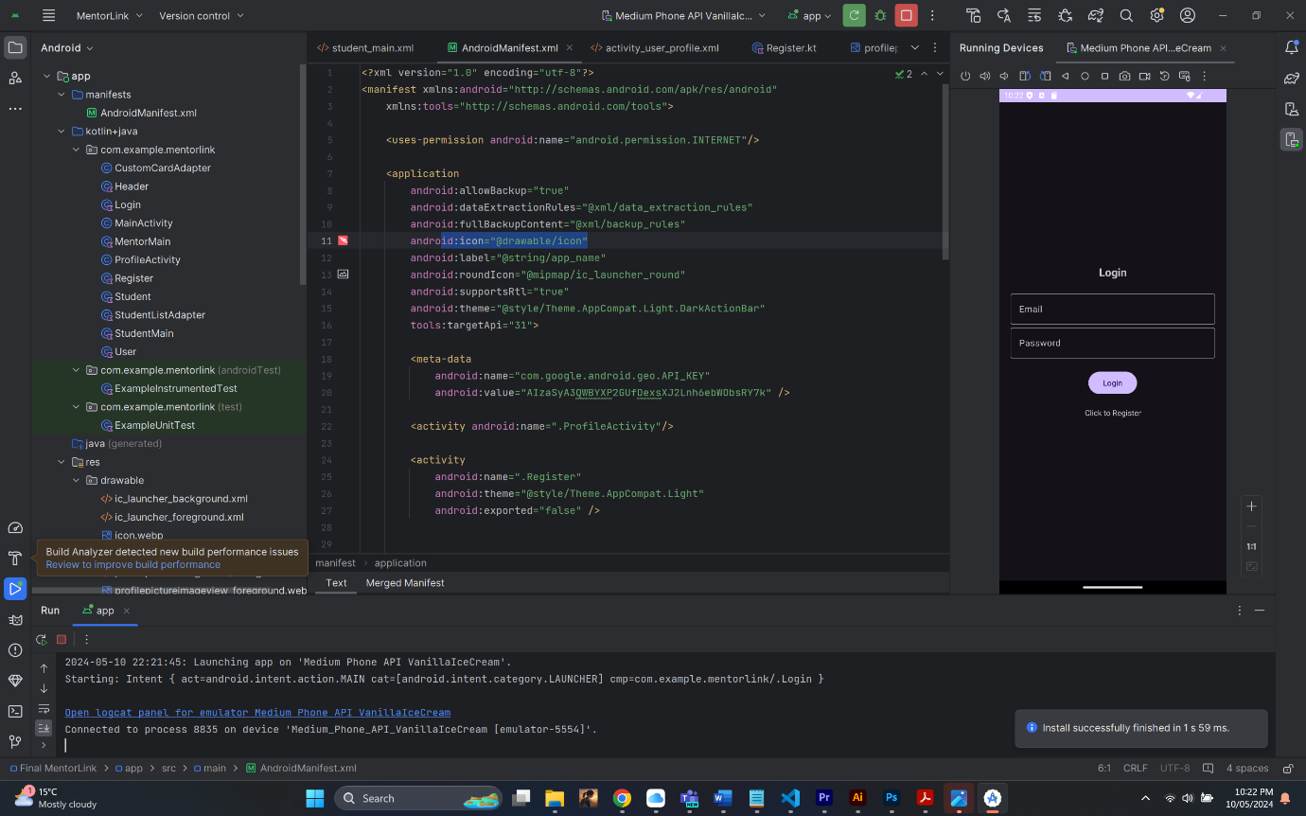

Figure 18 Login

I used Kotlin since it’s a powerful language mainly for building android applications. Although I had to learn a new language, I found it easier and quicker to code. XML is used to organize and describe the data that were in Kotlin files. XML is short for eXtensible Markup Language. It’s used widely for web development, data sharing and setting up softwares and screens.

## APIS:

### Android's Location APIs

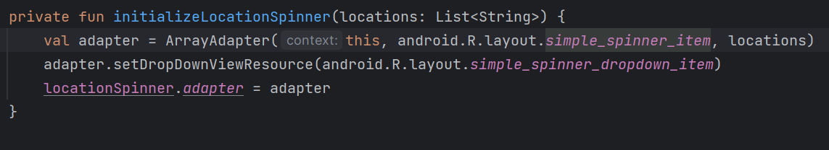

Figure 19 Location APIs

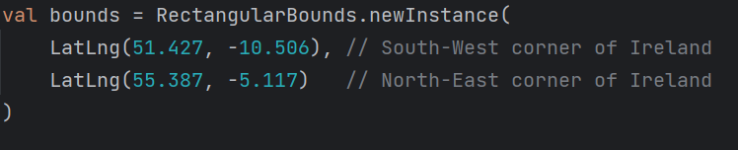

Figure 20 Location API

I used Android’s Location APIs in Google Development console to facilitate finding mentors and students on the basis of distance. For that purpose, I integrated initalizelocationSpinner with bounds set from south-west corner of Ireland which is LatLng(51.427.-10.506) to North-East Corner of Ireland which is LatLng (55.387, -5.117).

MentorLink uses Android's Location APIs to make the app better, like helping users find nearby mentors or mentees. But because I ran into some issues with other parts of the app, I decided to save integrating this feature for later.

Android's Location APIs give developers tools to add location-based stuff to their apps. MentorLink uses these tools to do things like finding mentors nearby or showing search results based on location. For example, in the app, there's a drop-down menu called "spanner object" that lists locations from southwest to northeast Ireland, helping users find what the user nearby.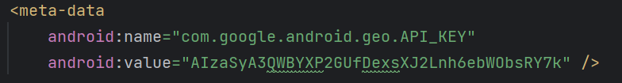

Figure 21 Menifest XML

By leveraging Android's Location APIs, MentorLink ensures precise and efficient location tracking, enabling users to connect with mentors or mentees in their vicinity effectively.

## Registering the user information and sending it to the Firebase Database

In the registration process of MentorLink, obtaining user information and securely transmitting it to the Firebase Database is a pivotal step in ensuring a seamless and personalized user experience. As users embark on their MentorLink journey, they provide essential details that not only facilitate account creation but also enable MentorLink to tailor its services to meet their unique needs and preferences. There are two ways the user can sign up. As a student or as a teacher. Each of these different options presents user with two registration screens:

* One for the student.
* One for the teacher.

I used JSON to create the user database blueprint.

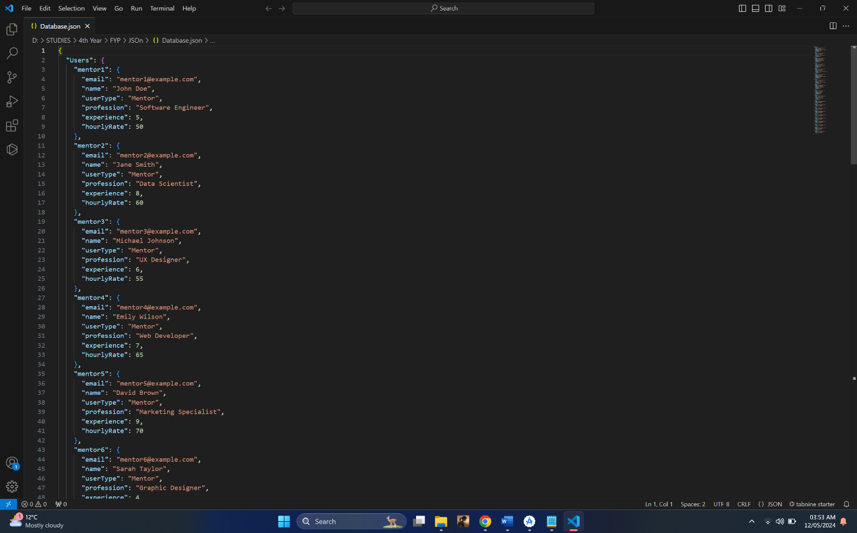

Figure 22 JSON

Register_activity.xml displayes different input fields for students and teachers. For Students Email, Password and Name is required whereas mentors has to additionally profile Profession, Experience and hourly rate. However, this sets up the foundation of mentorLink profile that can be matched by the student.

mAuth = FirebaseAuth.getInstance()  
databaseReference = FirebaseDatabase.getInstance().*reference*.child("UserID")

Upon submission of the registration form, mAuth = FirebaseAuth.getInstance() line initializes firebase authentication service where FirebaseAuth is a class by Firebase SDK used mostly to authenticate users that manage their sessions. The getInstace() obtains a singleton instance of FirebaseAuth that can be used to manage user details.

All the fields in Register.kt:

radioGroup = findViewById(R.id.*radioGroup*)  
radioButtonMentor = findViewById(R.id.*radioButtonMentor*)  
radioButtonStudent = findViewById(R.id.*radioButtonStudent*)  
  
editTextEmail = findViewById(R.id.*email*)  
editTextPassword = findViewById(R.id.*password*)  
editTextName = findViewById(R.id.*name*)  
editTextProfessions = findViewById(R.id.*professions*)  
editTextExperience = findViewById(R.id.*experience*)  
editTextHourlyRate = findViewById(R.id.*hourly_rate*)  
locationSpinner = findViewById(R.id.*locationSpinner*)  
  
profession = findViewById(R.id.*professions*)  
experience = findViewById(R.id.*experience*)  
hourlyRate = findViewById(R.id.*hourly_rate*)

Code to hide or show the fields based on the radio button input:  
radioGroup.setOnCheckedChangeListener **{** _, checkedId **->** when (checkedId) {  
 R.id.*radioButtonMentor* -> {  
 // If Mentor is selected, show profession, experience, and hourly rate fields  
 profession.*visibility* = TextView.*VISIBLE* experience.*visibility* = TextView.*VISIBLE* hourlyRate.*visibility* = TextView.*VISIBLE* }  
 R.id.*radioButtonStudent* -> {  
 // If Student is selected, hide profession, experience, and hourly rate fields  
 profession.*visibility* = TextView.*GONE* experience.*visibility* = TextView.*GONE* hourlyRate.*visibility* = TextView.*GONE* }  
 }  
**}**

Location API:

// Initializing Places SDK  
Places.initialize(*applicationContext*, getString(R.string.*google_maps_key*))  
val placesClient: PlacesClient = Places.createClient(this)  
val bounds = RectangularBounds.newInstance(  
 LatLng(51.427, -10.506), // South-West corner of Ireland  
 LatLng(55.387, -5.117) // North-East corner of Ireland  
)  
  
val request = FindAutocompletePredictionsRequest.builder()  
 .setCountry("IE")  
 .setLocationBias(bounds)  
 .build()

Progress bar:

progressBar = findViewById(R.id.*progressbar*)

This code created a onClickListener on a texview with theID LoginNow to open login activity after registration is successfully done:

val textView: TextView = findViewById(R.id.*loginNow*)  
textView.setOnClickListener **{** val intent = Intent(*applicationContext*, Login::class.*java*)  
 startActivity(intent)  
 finish()  
**}**

This code creates a new user account with email and password, then stores additional user data in the Firebase Realtime Database, and redirects to the login page upon successful registration; otherwise, it displays an error message. The Code Screen is this:

auth.createUserWithEmailAndPassword(email, password)  
 .addOnCompleteListener(this) **{** task **->** if (task.*isSuccessful*) {  
 val currentUser = auth.*currentUser* val userId = currentUser?.*uid* val userData = *hashMapOf*(  
 "name" *to* name,  
 "email" *to* email,  
 "userType" *to* userType,  
 "professions" *to* professions,  
 "experience" *to* experience,  
 "hourlyRate" *to* hourlyRate,  
 "password" *to* password // Add password to the user data  
 )  
  
 userId?.*let* **{** databaseReference.child(**it**).setValue(userData)  
 .addOnSuccessListener **{** Log.d(TAG, "User data added successfully")  
 val intent = Intent(this, Login::class.*java*)  
 startActivity(intent)  
 **}** .addOnFailureListener **{** e **->** Log.w(TAG, "Error adding user data", e)  
 Toast.makeText(this@Register, "Error adding user data", Toast.*LENGTH_SHORT*).show()  
 **}  
 }** } else {  
 progressBar.*visibility* = View.*GONE* Log.w(TAG, "createUserWithEmail:failure", task.*exception*)  
 Toast.makeText(*baseContext*, "Authentication failed.", Toast.*LENGTH_SHORT*).show()  
 }  
 **}**

And Firebase Authentication Screen is this:

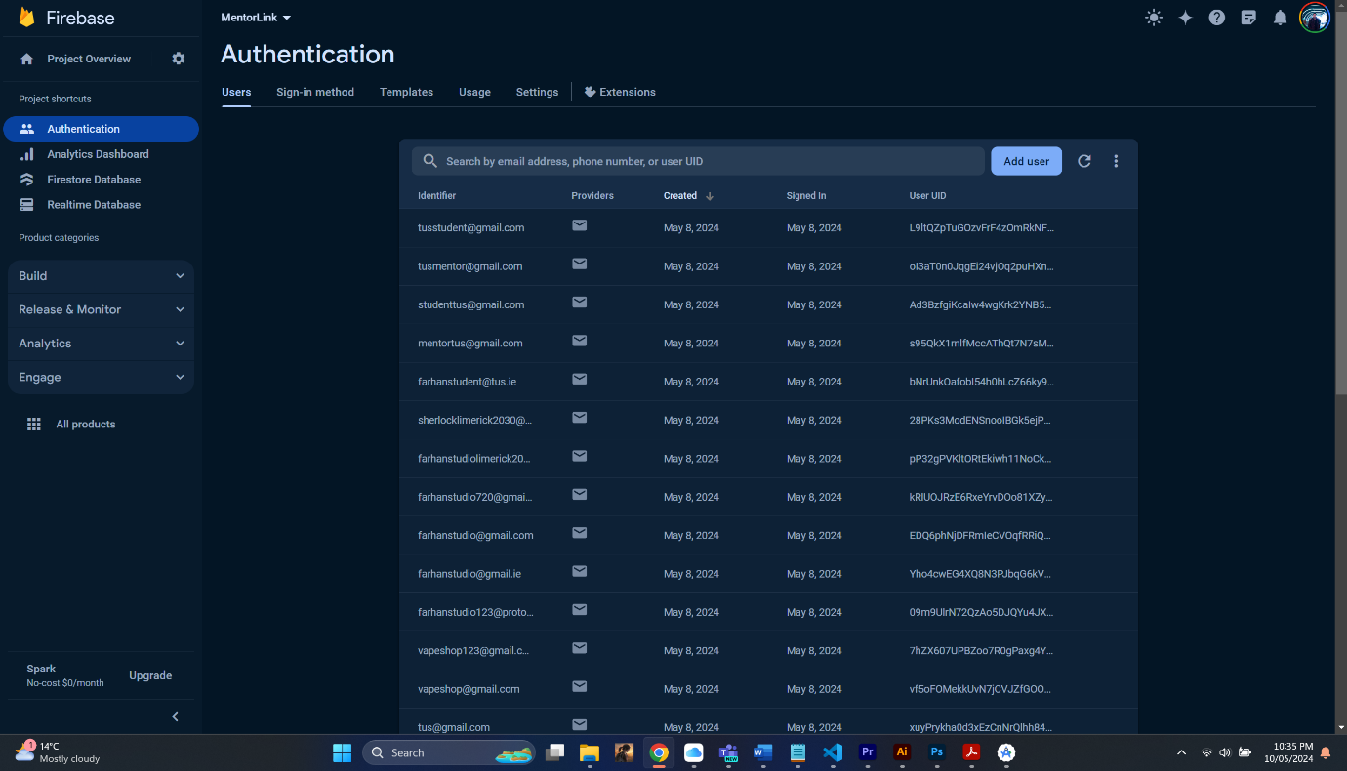

Figure 23 Authentication

Once stored in the Firebase Database, the user's information becomes accessible to login.

private fun registerUser(userType: String) {  
 val password: String = editTextPassword.*text*.*toString*()  
 val email: String = editTextEmail.*text*.*toString*()  
 val name: String = editTextName.*text*.*toString*()  
 val professions: String = editTextProfessions.*text*.*toString*()  
 val experience: Int = editTextExperience.*text*.*toString*().*toIntOrNull*() ?: 0  
 val hourlyRate: Int = editTextHourlyRate.*text*.*toString*().*toIntOrNull*() ?: 0  
  
 progressBar.*visibility* = View.*VISIBLE* if (TextUtils.isEmpty(email) || TextUtils.isEmpty(name) || TextUtils.isEmpty(password)) {  
 Toast.makeText(this@Register, "Please fill in all required fields", Toast.*LENGTH_SHORT*).show()  
 progressBar.*visibility* = View.*GONE* return  
 }

## Profile view:

In MentorLink's Android app, the profile view shows everything about a user - like who they are, what they know, and their work history. This information is coming from firebase realtime database. The profile view is made to be easy to use and looks nice, showing important details in an organized way.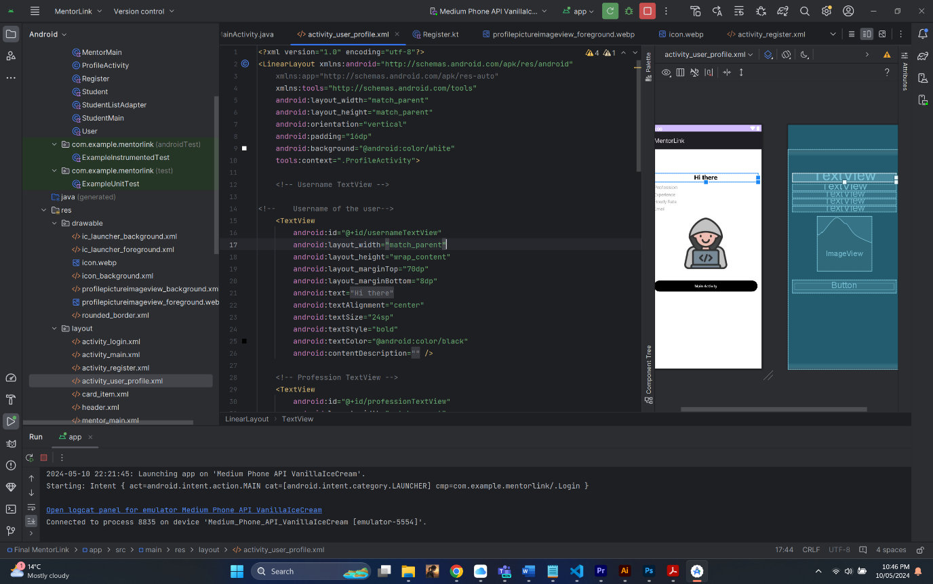

Figure 24 Profile View

In the profile view, users see their username at the top, shown in a bold Placeholder called “Hi there”. Below the username, users can find info about their job, experience, hourly rate, and email address. This gives a clear picture of their skills and qualifications for the students to see.

## Find a Mentor:

When a student logs in, they are greeted with find a mentor page. On this page, the student can find mentors in the proximity to the user.

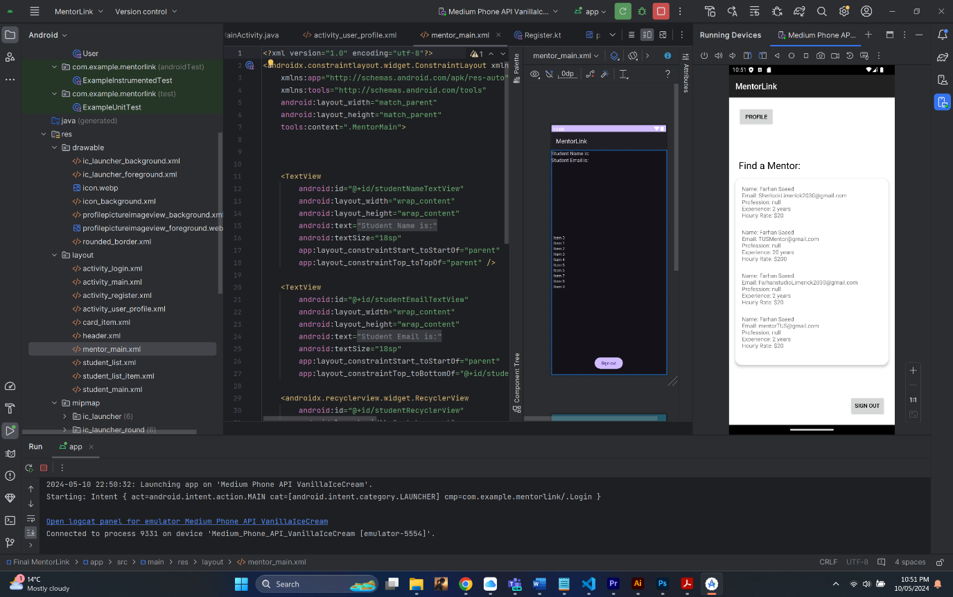

Figure 25 Find a mentor

# Lessons learned:

1. Kotlin, XML and Android Studio
2. Project management and planning.
3. UI Design
4. Firebase Database
5. Google Places API
6. Branding and Graphic Design

I used the following tutorials to create the app:

1. Login and Registration using Firebase in Android:

<https://www.youtube.com/watch?v=QAKq8UBv4GI&t=1426s>

1. Login and Signup using Firebase Realtime Database in Android Studio

<https://www.youtube.com/watch?v=M3gYcPF51QY>

1. Firebase:  
   <https://www.youtube.com/watch?v=tbh9YaWPKKs&list=PLlGT4GXi8_8dDK5Y3KCxuKAPpil9V49rN>